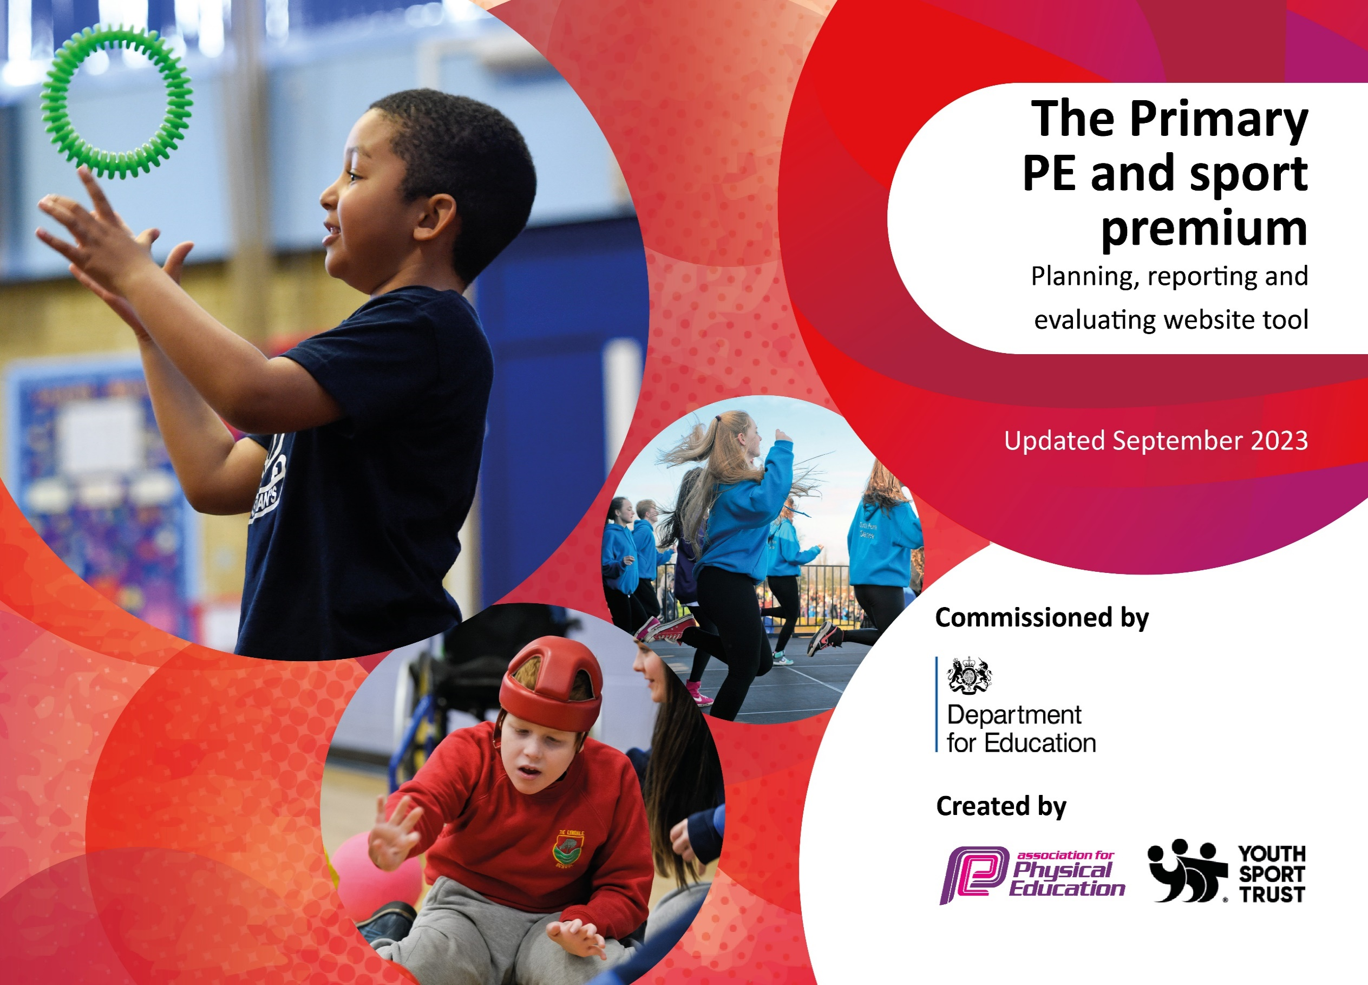


This template can be used for multiple purposes:
by:
- It enables schools to effectively plan their use of the Primary PE and sport premium
- It helps schools to meet the requirements (as set out in guidance) to publish information on their Primary PE and sport premium
- It will be an effective document to support Ofsted inspections enabling schools to evidence progress in Physical Education (PE) and evidence swimming attainment, which forms part of the PE National Curriculum. We would recommend schools consider
the Intent, Implementation and Impact of any spend, as examined within the Education Inspection Framework.

It is important that your grant is used effectively and based on school need.

Schools must use the funding to make additional and sustainable
improvements to the quality of the PE, School Sport and Physical Activity (PESSPA)
they offer. This means that you should use the Primary PE and sport premium to:

- Build capacity and capability within the school to ensure that improvements made now will benefit pupils joining the school in future years
- Develop or add to the PESSPA activities that your school already offers.

The Primary PE and sport premium should not be used to fund capital spend projects; the school’s core budget should fund these. Further detail on capital expenditure can be found in the updated Primary PE and sport premium guidance.

The Primary PE and sport premium guidance, outlines 5 key priorities that funding should be used towards. It is not

necessary that spending has to meet all the key priorities, you should select the priorities that you aim to use any funding towards.

Although completing this template is not a requirement for schools, schools are required to publish details of how they spend this funding. Schools must also outline what the impact this funding has had on pupils’ PE and sport participation and attainment and how any spending will be sustainable in the future. All funding must be spent by 31st July 2025.

The Department for Education has worked closely with the Association for Physical Education (afPE) and the Youth Sport Trust (YST) to develop this template and encourages schools to use it. This template is an effective way of meeting the reporting requirements of the Primary PE and sport premium.
Review of last year’s spend and key achievements (2024/2025)

We recommend you start by reflecting on the impact of current provision and reviewing your previous spend.

Activity/Action | Impact | Comments
Pupils have been taught PE by qualified coaches and all staff take in regular CPD through a mentoring approach to ensure the lessons are of a high quality.  Sessions completed around the areas of healthy eating, oral hygiene, physical activity and mental health.  - Healthy eating sessions were conducted with parents and promoted children to try new and unfamiliar foods. The children have completed lessons on healthy and unhealthy food.  - Oral hygiene - A dentist visited EYFS and discussed dental hygiene.  - Mental health – breathing techniques and mindful yoga  External sports events, remote sports events, sports day | Pupils participate in engaging high quality Physical Activity sessions each week. Pupils have had opportunities to try new activities and have engaged in this raising confidence.  .  Pupils develop an understanding of how physical activity leads to improved long term outcomes not only for physical health but mental and emotional wellbeing.  Pupil gain a broader experience of a range of sports and activities such as skipping workshops and yoga sessions. Participating in competition has helped the children build resilience, develop perseverance and have the skills to work as a team and listen to others | 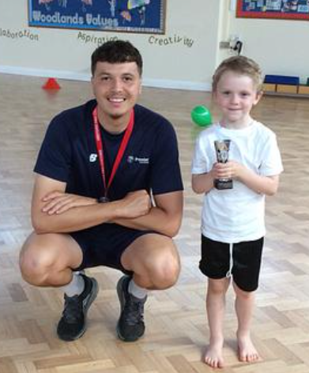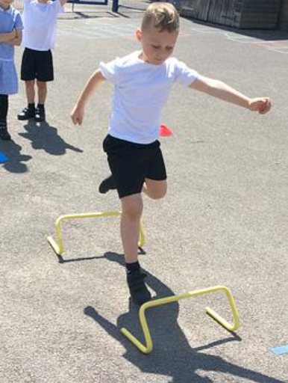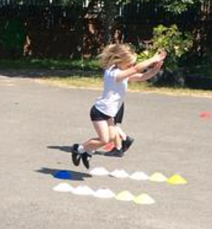  Inclusive sports - Boccia and seated volleyball  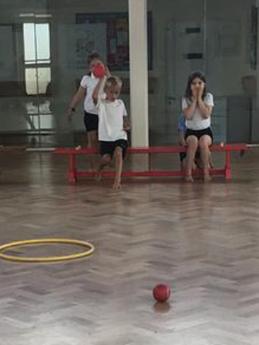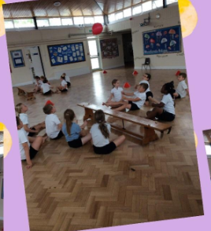  Visiting yoga instructor  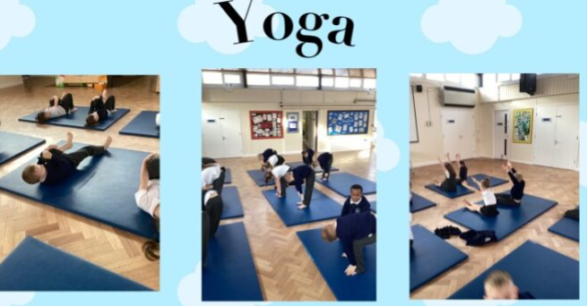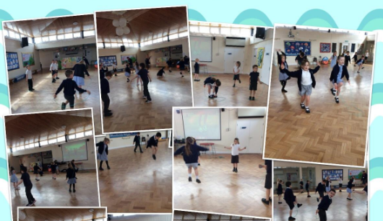  Visiting dentist – children learning about oral health  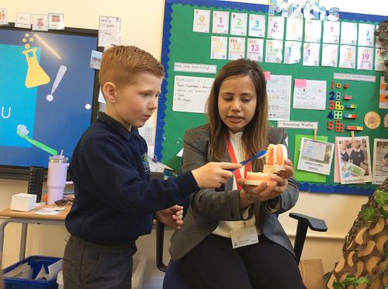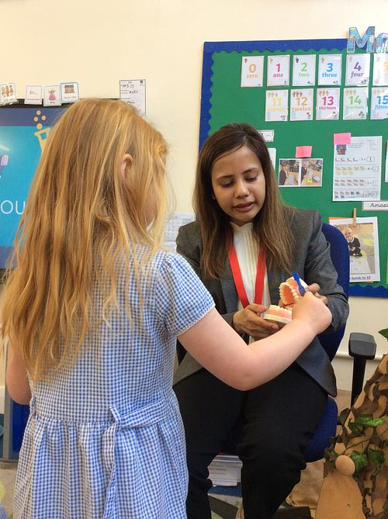  Healthy eating workshop with parents  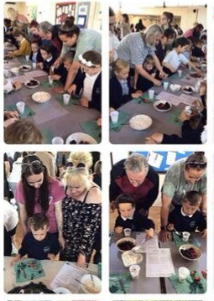  Sports day  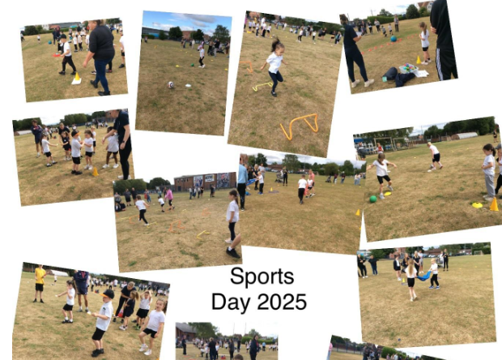  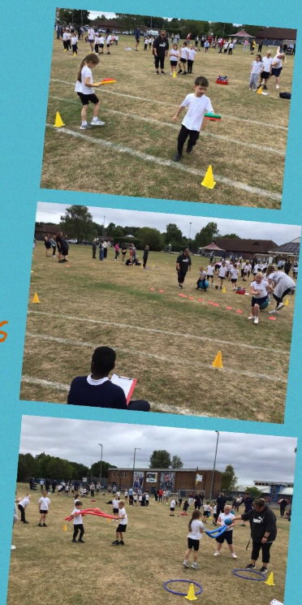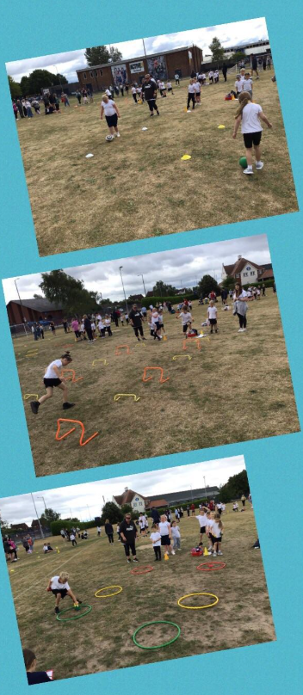  Remote competitions  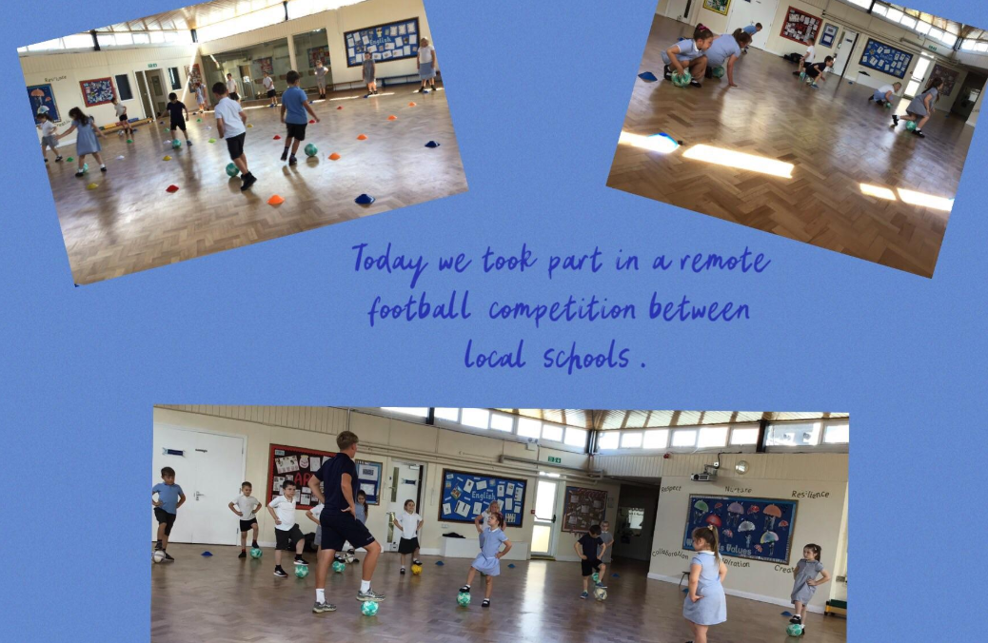  Sharing external sporting achievements  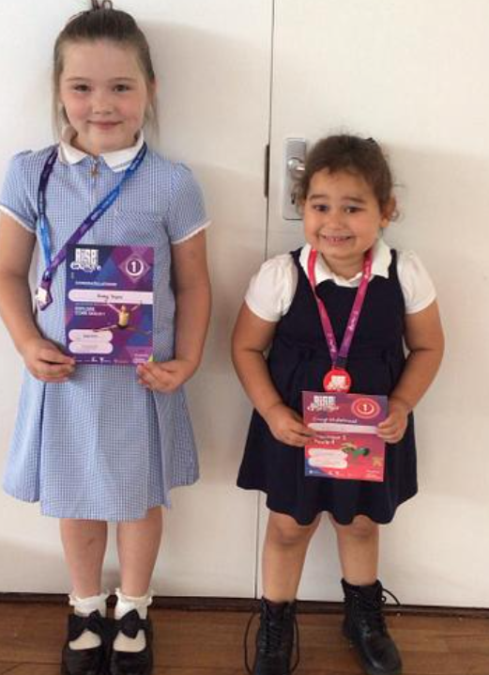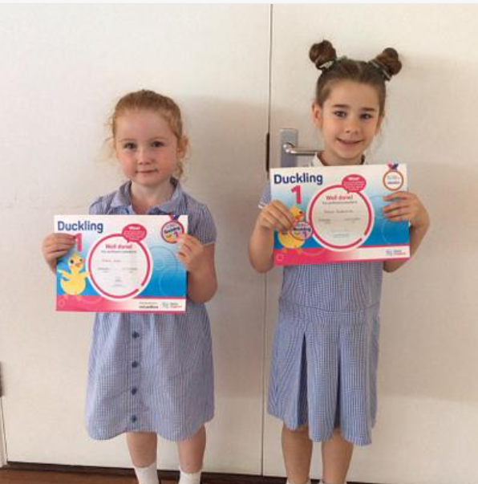

Key priorities and Planning
This planning template will allow schools to accurately plan their spending.

Action – what are you planning to do | Who does this action impact? | Key indicator to meet | Impacts and how sustainability will be achieved? | Cost linked to the action
Children participate in high quality Physical Activity sessions each week, enabling them to develop a variety of skills, resilience and perseverance.  Pupils develop an understanding of how physical activity leads to improved long term outcomes not only for physical health but mental and emotional wellbeing.  Pupils have a positive and skilled role models that inspire them to extend skills further.  Children have had the opportunity to compete competitively within school and between schools. They have the resilience to understand winning, losing and taking part.  Pupils have had opportunities to try new activities and have engaged in this raising confidence.  After school clubs to offer a variety of active options and promote healthy lifestyles.  Visitors to inspire and provide opportunities for developing confidence, skills and perseverance at a new sporting activity. | Children are taught PE by qualified coaches and all staff will part take in a mentoring approach to ensure the lessons are of a high quality.  Premier sport will provide Lunchtime activities that are structured and varied to enable children to be physically active. Lunch time staff will provide equipment for children to engage with, which are varied throughout the week/term. This will enable children to be physically actives.  Lesson in school based on developing an understanding of being fit and healthy as well as mental and emotional well being such as wellbeing day, healthy eating activities.  Children to take to part take in inter school sporting event to promote sports, self-esteem and confidence. Cost of transport to get children to local sports facilities.  Premier sport to continue to work alongside staff completing the mentoring approach to ensure the delivery of high quality PE lessons across the school.  Premier sport and teaching staff to follow the breakdown of sports created to ensure lessons are progressive across the school.  Premier sport and teaching staff assess again the Progression model.  Children to part take in inter school sporting event to promote sports, self esteem and confidence.  Children to take part in sports day.  Children to have access to a range of sports through PE lessons, lunch time and after school club.  Link with Birchwood Juniors sports ambassadors to complete sporting | Key indicator 1: The engagement of all pupils in regular physical activity – Chief Medical Officers guidelines recommend that primary school pupils undertake at least 30 minutes of physical activity a day in school  Key indicator 2: The profile of PESSPA being raised across the school as a tool for whole school improvement  Key indicator 3: Increased confidence, knowledge and skills of all staff in teaching PE and sport.  Key indicator 4: Broader experience of a range of sports and activities offered to all pupils.  Key indicator 5: Increased participation in competitive sport | More pupils meeting their daily physical activity goal, more pupils encouraged to take part in PE and Sport Activities.  Teachers more confident to deliver effective PE supporting pupils to undertake extra activities inside and outside of school.  Pupils understanding that physical activity will help them and breathing techniques support mental health.  Pupils have the skills needed to manage daily activities.  Staff training and  development to support long term planning and provision to ensure it is rich and varied.  Staff have the CPD and skills to deliver high quality PE.  Encouraging perseverance and resilience and regular attendance at an activity.  Pupils build a resilient attitude and have the skills to work as a team and listen to others. | £8000 for premier sport to carry out CPD, and active lunchtimes.  £`165 maintenance of equipment.  £400 Yoga teacher for mindful Monday.  £400 skipping workshop  £4500 Development of PE  £150 medals for sporting competitions.  £500 Transport.  £400 key stage 1 competitions.  Yoga coach and skipping man (cost already included)

Key achievements 2025-2026
This template will be completed at the end of the academic year and will showcase the key achievements schools have made with their Primary PE and sport premium spending.

Activity/Action | Impact | Comments

Signed off by:

Head Teacher: | Joanne Bingwa
Subject Leader or the individual responsible for the Primary PE and sport premium: | Miss V Batten (EYFS lead)  Joanne Bingwa
Governor:
Date:

